Branching makes it easy to work within self-contained contexts, but often we want to incorporate changes from one branch into another.
git merge
- We merge branches, not specific commits
- We always merge to the current HEAD branch
git switch main
git merge bugfix

- Switch to or checkout the branch you want to merge the changes into (the receiving branch)
- Use the git merge command to merge changes from a specific branch into the current branch.

Fast Forward Merge
When there’s nothing on the main that’s been committed and the branch being work on is merged to that branch after a few extra commits.
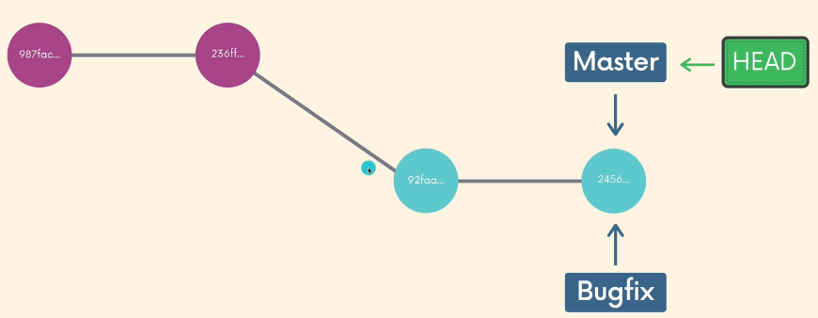
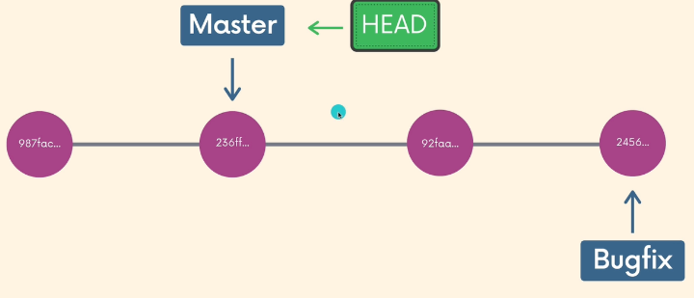
All we do is catch up the main branch. (Fast Forward)
- It transfers the work history that was on the bugfix branch

Merge Commits
What happens when we try to merge a branch to main when has more data we don’t have on our branch.
Rather than performing a simple fast forward, git performs a “merge commit” We end up with a new commit on the main branch.
- Git will prompt us for a message.
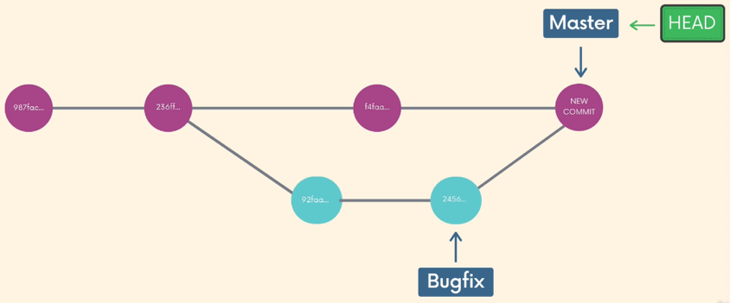
Depending on the specific changes you are trying to merge, Git may not be able to automatically merge. This results in merge conflicts, which you need to manually resolve.
When you encounter a merge conflict, Git warns you in the console that it could not automatically merge.

CONFLICT(content): Merge conflict in example.txt
Automatic merge failed; fix conflicts and then commit the result.

It also changes the contents of your files to indicate the conflicts that it wants you to resolve.

